CP Security Implementation Process – iOS
Demo1 : 12/May/2020 | Demo2 : 20/May/2020
Lock Process – Success  Unlock Process – Failed | Lock Process – Success  Unlock Process – Success
Description  Multiple user access for same device failed.  One user locks the device after scanning  QR code and logout.  Another user was able to access the same  QR Code and able to do the Locking Process.  "Device Authentication Error" occurred. | Description  Successful demo of the “Check IN” & “Check Out” sequence with full security Implementation process.  Additional validations added including the "Waiting for Putting Lever down" message.
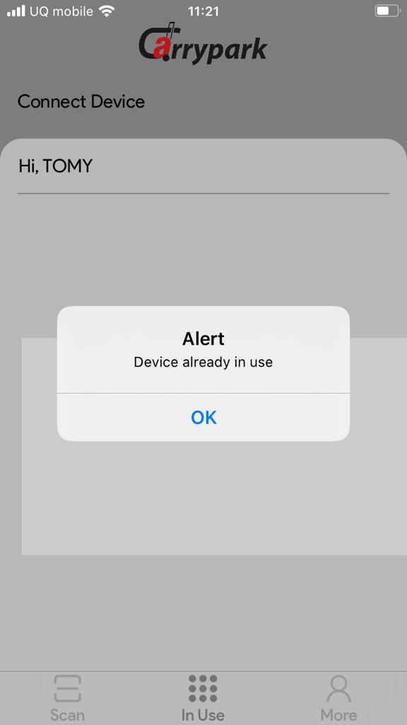 | 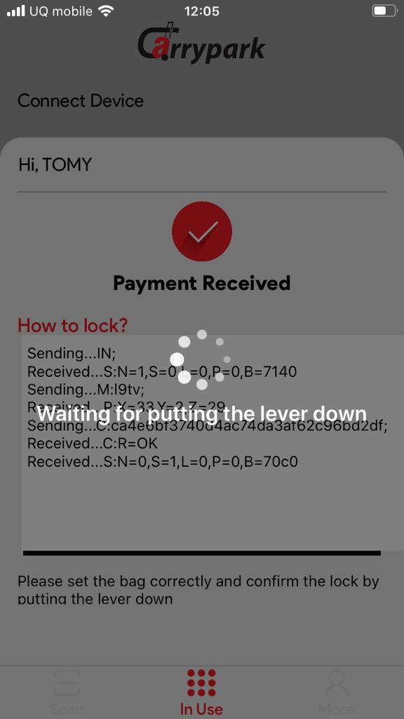

Version 1 – May-12-2020
1 - Locking Process
Step 1:
Send “IN;”
Received Message: “S: N=1, S=0, L=0, P=0, B=5340”
Checking the battery power using 3.3V*(value reported/0xffff)*(43/10)
When the battery power goes below 4.5V then display the alert “Battery power is low” and disconnect from the BLT connection.
If the battery power is normal then app proceeds with the payment procedure and starts the locking procedure.
Step 2:
Send “M:ABCD;”
Received Message: “P: X=15, Y=5, Z=5”.
Receives the above response from BLT device random table.
- X means starting position,
- Y means total length of the string
- Z is the gap between each no.
BLT devices create “MSG2” using XYZ values and apply MD5 Algorithm on Close, MSG1, XYZ and MSG2 (close +MSG1+XYZ) and creates the hash values.
After receiving value of XYZ. App call an API for generating Hash value. That API parameters are
- device_id= BLT device ID
- command_text = close
- random_app_key = MSG1
- starting_position = Value of X
- key_string_length = = Value of Y
- skip_chars = = Value of Z
- User_ID = ID of user
The API response is a hash value. That hash value send to the BLT device C:<Hash Values>

Step 3:
Send “C:<Hash Values>;”
Received Message: “C:R=OK”
“S:N=0,S=1,L=0,P=0,B=69c0”

C: R=OK means the hash value comparison is success else return “C:R=NG”
Now the value of “S” is changed 0 to 1 which means hash value saved in the BLT device.
Step 4:
After verifying Hash value app waiting for the BLT device for manual locking operation. APP check status of the BLT device using “st;” commands in every 10 seconds of intervals until completing the manual locking process. After manual lock status would be “S:N=0,S=1,L=1,P=0,B=69c0”
Send “st;”
Received Message: “S:N=0,S=1,L=1,P=0,B=69c0”.
Now value of “S” & “L” values are 1, which means locking procedure completed.
Step 5:
Send “MM;”
After getting the response “S: N=0,S=1,L=1,P=0,B=69c0” app send “MM” command and starts billing.
2 - Unlocking Process
Step 1:
After scanning the QR code it checks the server to device authorization.
Send “I: <saved hash value>”
Received Message: “S: N=0, S=1, L=1, P=0, B=69c0”
If the hash value not match BLE device return like “ER, msg1=, msg2=” which means device authorization failed. Then app show an alert “Device Authorization Failed” and disconnect from the BLE device
If BLT device authorization is success then app navigate to payment screen and complete payment procedure
Step 2:
Tap the Unlock button for the following process:
Send “M: EFGH”
Received Message: “P: X=15, Y=5, Z=5”
Receives the above response from BLT device random table.
- X means starting position,
- Y means total length of the string
- Z is the gap between each no.
BLT devices create MSG2 from XYZ and apply MD5 Algorithm on Close, MSG1, XYZ and MSG2 (open+MSG1+XYZ) and create hash values.
After receiving value of XYZ. App call an API for generating Hash value. That API parameters are
- device_id= BLT device ID
- command_text = open
- random_app_key = MSG1
- starting_position = Value of X
- key_string_length = = Value of Y
- skip_chars = = Value of Z
- User_ID = ID of user
And API response is a hash value. That hash value send to the BLT device “O: <Hash Values>”
Step 3:
Send “O:<Hash Values>;”
Received Message: “O:R=OK”
“S:N=1,S=0,L=0,P=0,B=69c0”

BLT App checks the received string with saved hash values.
If both are matching then send Ok along with a status response to BLE APP. Response would be like
- “O:R=OK “
- “S:N=1,S=0,L=0,P=0,B=69c0”
O: R=OK means the hash value comparison is success else return “O: R=NG”
Now the value of “S” & “L” changed 1 to 0 which means locker is unlocked.
Step 4:
Send “RR;”
After getting the response “S:N=1,S=0,L=0,P=0,B=69c0” app send “RR” command and update device status in server and disconnect from that BLE device

Version 2 – May-21-2020
1 - Locking Process
Step 1:
Send “IN;”
Received Message: “S: N=1, S=0, L=0, P=0, B=5340”
App check the value of “S” and “L” are 0
If value of “S” & “L” are not 0 then display a alert with message "Device in use" and
Check the battery power using 3.3V*(value reported/0xffff)*(43/10)
When the battery power is below 4.5V then display an alert “Battery power is low” and disconnect from the BLT connection
If Battery power and values of S & L are okay then app complete the payment procedure and start locking procedure.
Step 2:
Send “M:ABCD;”
Received Message: “P: X=15, Y=5, Z=5”.
The above response from BLT device random table.
- X means starting position,
- Y means total length of the string
- Z is the gap between each no.
BLT devices create MSG2 from XYZ and apply MD5 Algorithm on Close, MSG1, XYZ and MSG2 (close +MSG1+XYZ) and create hash values.
After receiving value of XYZ. App call an API for generating Hash value. That API parameters are
- device_id= BLT device ID
- command_text = close
- random_app_key = MSG1
- starting_position = Value of X
- key_string_length = = Value of Y
- skip_chars = = Value of Z
- User_ID = ID of user
And API response is a hash value. That hash value send to the BLT device C:<Hash Values>

Step 3:
Send “C:<Hash Values>;”
Received Message: “C:R=OK”
“S:N=0,S=1,L=0,P=0,B=69c0”
C: R=OK means the hash value comparison is success else return “C:R=NG”
Now the value of “S” is changed 0 to 1 which means hash value saved in the BLT device
Step 4:
After verifying Hash value app waiting for the BLT device manual lock. APP check status of the BLT device using “st;” commands in every 10 seconds of intervals until completing the manual lock. After manual lock status would be “S:N=0,S=1,L=1,P=0,B=69c0”
Send “st;”
Received Message: “S:N=0,S=1,L=1,P=0,B=69c0”.
Now value of “S” & “L” are 1 which means locking procedure completed.
Step 5:
Send “MM;”
After getting the response “S: N=0,S=1,L=1,P=0,B=69c0” app send “MM” command and start billing.

Case1: Lock -> Completing payment -> EXIT from the app - > Re – open the APP and try to lock

The above case Scan the QR code and connect to the BLT device
(Note: After payment the device will be owned by the paid user for 1 hour. After 1 hour even if the baggage is not locked the device will be released and status will be changed to "Idle”)
- If one device is completed the payment then that BLT device details is saved on the current user details.
- If one device is saved in the user details and not completed the locking process, app checking the current status of the BLT device after established a connection
Step 1:
Send “st;”
Received Message: “S:N=0,S=0,L=0,P=0,B=69c0”.

- After Checking the BLT device status that would be “S:N=0,S=0,L=0,P=0,B=69c0” and navigate to Video Instruction screen and app go to Lock screen that means payment screen not appears
- Taping Lock button app execute security process same as Normal flow
Case2: Lock -> Completing payment ->Tap the Lock button -> at the time of waiting for manual lock -> EXIT from the app - > Re – open the APP and try to lock

The above case Scan the QR code and connect to the BLT device.
(Note: After payment the device will be owned by the paid user for 1 hour. After 1 hour even if the baggage is not locked the device will be released and status will be changed to "idle”)
- If one device is completed the payment then that BLT device details is saved on the current user details.
- If one device is saved in the user details and not completed the locking process, app checking the current status OF the BLT device after established a connection

Step 1:
Send “st;”
Received Message: “S:N=0,S=1,L=0,P=0,B=69c0”.
- After Checking the BLT device status that would be “S:N=0,S=1,L=0,P=0,B=69c0” and navigate to Video Instruction screen and app go to Lock screen that means payment screen not appears
- Taping Lock button app display a message “Waiting for putting the lever down”.
APP check status of the BLT device using “st;” commands in every 10 seconds of intervals until completing the manual lock

Step 2:
Send “MM;”
Received Message: “S:N=0,S=1,L=1,P=0,B=69c0”.
Now value of “S” & “L” are 1 which means locking procedure completed.
Step 3:
After getting the response “S: N=0, S=1, L=1, P=0, B=69c0” app send “MM” command and starts the billing.
After sending “MM” app update to the server for BLT device is locked and start billing
Case3: Lock -> Completing payment ->Tap the Lock button -> at the time of waiting for manual lock -> EXIT from the app - > Done the manual lock -> Re – open the APP and try to lock

The above case Scan the QR code and connect to the BLT device
(Note: After payment the device will be owned by the paid user for 1 hour. After 1 hour even if the baggage is not locked the device will be released and status will be changed to "idle”)
- If one device is completed the payment then that BLT device details is saved on the current user details.
- If one device is saved in the user details and not completed the locking process, app checking the current status OF the BLT device after established a connection
Step 1:
Send “st;”
Received Message: “S:N=0,S=1,L=1,P=0,B=69c0”.
- After Checking the BLT device status that would be “S:N=0,S=1,L=1,P=0,B=69c0” and navigate to Video Instruction screen and app go to Lock screen that means payment screen not appears
Step 2:
Send “MM;”
By tap the Lock button app send “MM” command to BLT device and start Billing.
After sending “MM” app update to the server for BLT device is locked and Log out the app
2 - Unlocking Process

Step 1:
After scanning the QR code, app checks correct device is scanned or not.
Send “I: <saved hash value>”
Received Message: “S: N=0, S=1, L=1, P=0, B=69c0”
If the hash value not match BLE device return like “ER, msg1=, msg2=” which means device authorization failed. Then app show an alert “Device Authorization Failed” and disconnect from the BLE device
If BLT device authorization is success then app navigate to payment screen and complete payment procedure
Step 2:
By tapping the Unlock button

Send “M: EFGH”
Received Message: “P: X=15, Y=5, Z=5”

The above response from BLT device random table.
- X means starting position,
- Y means total length of the string
- Z is the gap between each no.
BLT devices create MSG2 from XYZ and apply MD5 Algorithm on Close, MSG1, XYZ and MSG2 (open+MSG1+XYZ) and create hash values.
After receiving value of XYZ. App call an API for generating Hash value. That API parameters are
- device_id= BLT device ID
- command_text = open
- random_app_key = MSG1
- starting_position = Value of X
- key_string_length = = Value of Y
- skip_chars = = Value of Z
- User_ID = ID of user
And API response is a hash value. That hash value send to the BLT device “O: <Hash Values>”
Step 3:
Send “O:<Hash Values>;”
Received Message: “O:R=OK”
“S:N=1,S=0,L=0,P=0,B=69c0”
BLT App checks the received string with saved hash values.
If both are matching then send Ok along with a status response to BLE APP. Response would be like
- “O:R=OK “
- “S:N=1,S=0,L=0,P=0,B=69c0”
O: R=OK means the hash value comparison is success else return “O: R=NG”
Now the value of S & L changed 1 to 0 which means locker is unlocked
Step 4:
Send “RR;”
After getting the response “S:N=1,S=0,L=0,P=0,B=69c0” app send “RR” command and update device status in server and disconnect from that BLE device

